**Task 7**

7. Rendering Lists

Tasks:

1. Write a component that takes an array of names as a prop and displays them

in a list.

**ArrayToList.jsx**

import React from 'react'

export default function ArrayToList(props) {

return (

<ul>

{props.names.map((name) => (

<li>{name}</li>

))}

</ul>

)

}

**Main.jsx**

import ArrayToList from './ArrayToList.jsx'

const names=["Apple","Orange","Watermelon","Pineapple"]

createRoot(document.getElementById('root')).render(

<StrictMode>

<ArrayToList names={names}/>

</StrictMode>

)

**Output**

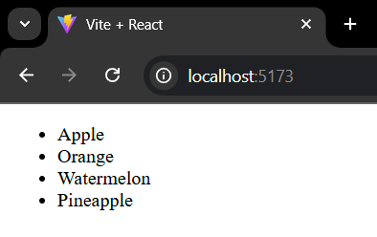

2. Create a TodoList component that displays a list of tasks and marks the

completed ones.

**TodoList.jsx**

import React from 'react'

export default function TodoList(props) {

return (

<>

<ol>

{props.tasks.map((task) => (

<li style={{

textDecoration : task.isCompleted ? "line-through" : "none"

}}> {task.name} </li>

))}

</ol>

</>

)

}

**Main.jsx**

import TodoList from './TodoList.jsx'

const tasks = [

{name:"HomeWork",isCompleted:true},

{name:"Project",isCompleted:false},

{name:"Report",isCompleted:true}

]

createRoot(document.getElementById('root')).render(

<StrictMode>

<TodoList tasks={tasks}/>

</StrictMode>

)

**Output**

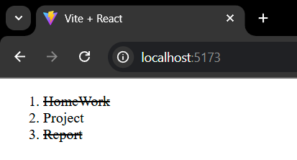

3. Design a ProductList component that only displays products with a price less

than $10 using the filter() method.

**ProductList.jsx**

import React from 'react'

export default function ProductList(props) {

const showCaseProduct = props.products.filter(product=>product.price<10)

return (

<>

<ul>

{showCaseProduct.map((product)=>(

<li>{product.name}</li>

))}

</ul>

</>

)

}

**Main.jsx**

import ProductList from './ProductList.jsx'

const products = [

{name:"Laptop",price:1000},

{name:"Phone",price:500},

{name:"Pen",price:2},

{name:"Rice Flour",price:8},

]

createRoot(document.getElementById('root')).render(

<StrictMode>

<ProductList products={products} />

</StrictMode>

)

**Output**

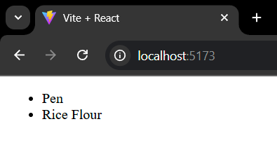

4. Make a UserList component that takes an array of user objects and displays

their names and emails.

**UserList.jsx**

import React from 'react'

export default function UserList(props) {

return (

<>

<ul>

{props.content.map((content) => (

<li>{content.name}:&nbsp;&nbsp;{content.email}</li>

))}

</ul>

</>

)

}

**Main.jsx**

import UserList from './UserList.jsx'

const contents = [

{name:"Thor",email:"thor@gmail.com"},

{name:"Iron Man",email:"ironman@gmail.com"},

{name:"Captain America",email:"captainamerica@gmail.com"},

{name:"Hulk",email:"hulk@gmail.com"},

]

createRoot(document.getElementById('root')).render(

<StrictMode>

<UserList content={contents} />

</StrictMode>

)

**Output**

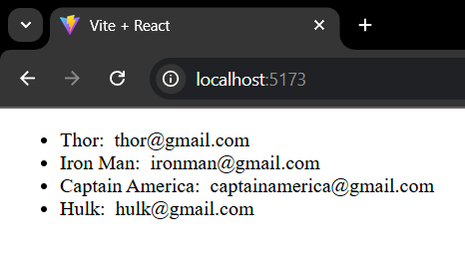

5. Create a ShoppingCart component that displays a list of items and their prices.

Ensure each item has a unique key.

**ShoppingCart.jsx**

import React from 'react'

export default function ShoppingCart(props) {

return (

<>

<ul>

{props.content.map((content) => (

<li key={content.id}>{content.name}:&nbsp;&nbsp;{content.price}</li>

))}

</ul>

</>

)

}

**Main.jsx**

import ShoppingCart from './ShoppingCart.jsx'

const products = [

{id:1,name:"Phone",price:25000},

{id:2,name:"PC",price:75000},

{id:3,name:"Laptop",price:65000},

{id:4,name:"Charger",price:1500},

]

createRoot(document.getElementById('root')).render(

<StrictMode>

<ShoppingCart content={products} />

</StrictMode>

)

**Output**

